Combustion Enthalpy Experiment – Eden Tomes

# Research Question:

*How does the number of carbon atoms present in a chemical compound affect the enthalpy of combustion?*

# Rationale:

Combustion reactions, which involve the exothermic oxidation of fuels, are essential for energy production in industries, transportation, and everyday applications. The enthalpy of combustion ($∆H°C$), defined as the energy released per mole of a substance during complete combustion, is an important parameter for evaluating fuel efficiency and environmental impact (*Atkins & de Paula*, 2010). Carbon, a primary component of hydrocarbons and organic fuels, plays a key role because its oxidation to carbon dioxide releases significant heat (*Glassman & Yetter*, 2008). While much research has focused on pure fuels, there is a gap in our understanding of how variations in carbon amounts within different alcohols influence combustion energetics.

This experiment is the product of several modifications made to a base experiment that involved investigating the enthalpy of combustion for different foods, including alteration of the substances tested and the use of a more reliable experimental method (the addition of a heat shield, conducting multiple trials). This modified experiment investigates the enthalpy of combustion for a series of alcohols: ethanol, pentanol, and methanol, using calorimetry measurements. The study is designed to show the effect of varying carbon amounts on the energy released during combustion. These modifications enhance the effectiveness of the experiment in testing the new research question.

Understanding how carbon molecules affect a chemical’s enthalpy of combustion has implications for the formulation and optimization of fuels. Insights into combustion can help areas such as biofuel production and energy systems, where balancing energy density, cost, and emissions is important (*IEA*, 2021). In addition, the experimental data will contribute to the broader field of thermochemistry by providing evidence that can help with predictive models in combustion science.

# Method:

***Original Experiment***

The original experiment aimed to determine the enthalpy of combustion of solid food samples using a simple calorimetry setup. A test tube clamped above a food tray held 10 mL of water, measured via a glass thermometer and 10 mL measuring cylinder. The initial water temperature was recorded, and the pre-weighed food (e.g., nuts, crisps) was ignited using a Bunsen burner. Once aflame, the food was positioned 2 cm beneath the test tube, and the temperature change was monitored. After combustion ceased, the final water temperature was recorded, and the mass of the burned food was measured. Observations of flame color and soot deposition were noted. The heat absorbed by the water   
() was calculated, and the enthalpy of combustion per gram of food was derived. Only one trial per food type was conducted, and no heat shield was used, leading to potential heat loss.

## Modifications

The modified experiment replaced solid foods with liquid alcohols (ethanol, pentanol, methanol) and incorporated enhancements to improve accuracy. A heat shield surrounded the setup to minimize heat loss, a digital thermometer replaced the glass one for precise temperature readings, and each alcohol was tested in three trials to ensure reliability.

***Modified Experiment***

The experiment setup used a spirit burner containing the alcohol, with initial and final masses recorded to determine the amount of fuel consumed. For each trial, approximately 200 grams of water was measured in a beaker and then heated in a metal can clamped above the burner. After ignition, the flame heated the water until its temperature had risen by a certain amount (20 degrees for ethanol and pentanol, 10 degrees for methanol). Temperature changes were recorded digitally, and the enthalpy of combustion ($∆H°C$) was calculated per gram using .

# Risk Management:

The experiment used highly flammable alcohols (methanol, ethanol, pentanol) and an open flame, posing fire and burn risks. Alcohol spills or burner malfunctions could ignite accidental fires and contact with the flame or heated apparatus could cause burns. To mitigate these hazards, flammable liquids were handled in a well-ventilated area away from ignition sources, and safety glasses were always worn. A heat shield contained the flame, and tongs were used to handle hot equipment. A fire extinguisher and fire blanket were kept nearby.

Uncontrolled combustion might damage laboratory equipment and structures, so the experiment was conducted on a non-flammable surface, free of combustible materials. Spillage and glassware breakage were also risks, potentially causing fire or injury from broken glass. Alcohols were dispensed carefully, and a metal can replaced fragile glass test tubes. Constant monitoring ensured quick intervention if hazards arose, minimizing the likelihood of fire spread or equipment damage.

# Results:

Figure 1 (Results Table):

|  |  |  |  |  |  |
| --- | --- | --- | --- | --- | --- |
| **Alcohol** | **Carbon Atoms** | **Average Combustion Enthalpy (kJ/g)** | **Mol. Weight (g/mol)** | **Theoretical Value (kJ/g)**  **(*NIST*, 2023)** | **% Error** |
| Methanol | 1 | -6.29 ± 0.34 | 32.04 | -22.65 | 72.2% |
| Ethanol | 2 | -5.91 ± 0.20 | 46.07 | -29.69 | 80.1% |
| Pentanol | 5 | -11.70 ± 0.64 | 88.15 | -37.79 | 69.0% |

Figure 2 (Num. Of Carbon Atoms vs Combustion Enthalpy):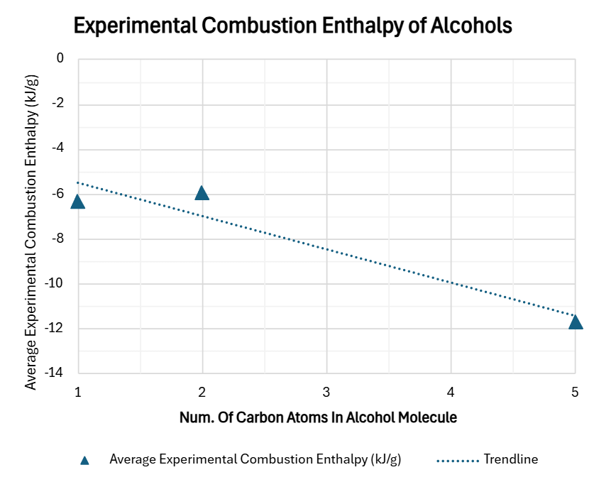

Figure 1 contains the average experimental combustion enthalpies of the alcohols, along with the number of carbon atoms in their molecules. The data displays a clear trend: as the number of carbon atoms increases from one (methanol) to five (pentanol), the average experimental combustion enthalpy becomes more negative, indicating a larger amount of energy released per gram of alcohol. Methanol, with one carbon atom, exhibits an average combustion enthalpy of -6.29 kJ/g. Ethanol, containing two carbon atoms, shows a similar value of -5.91 kJ/g. Pentanol, with five carbon atoms, demonstrates the most negative average combustion enthalpy of -11.70 kJ/g.

The graphical representation in Figure 2 visually confirms this observation, depicting a trendline with a downward slope as the number of carbon atoms increases. While there is a similarity in the experimental values for methanol and ethanol, the combustion enthalpy of pentanol is notably more exothermic, approximately 1.98 times greater than that of ethanol and 1.86 times greater than methanol. This quantitative difference highlights the substantial impact of increasing carbon chain length on the energy released during combustion within this series of alcohols. The visual representation in Figure 2, alongside the numerical data in Figure 1, supports the hypothesis that increasing carbon atoms in alcohol molecules leads to a greater magnitude of combustion enthalpy.

## Theoretical Explanation

The combustion of alcohols involves breaking bonds (such as C–H and C–C) and forming new bonds in the products, notably in carbon dioxide and water. Theoretically, as the number of carbon atoms increases, the total energy released during these bond rearrangements should also increase, leading to a more exothermic reaction (*Glassman & Yetter*, 2008). The observation that pentanol shows a larger magnitude of combustion enthalpy is consistent with this theoretical expectation. However, the near-identical values for methanol and ethanol indicate that experimental data contains anomalies/outliers.

# Evaluation of Evidence:

The experimental results indicate a trend of increasing combustion enthalpy with a higher number of carbon atoms in alcohol molecules. Pentanol (5 carbon atoms) demonstrated a significantly more exothermic combustion enthalpy compared to methanol (1 carbon) and ethanol (2 carbons), aligning with theoretical predictions based on bond enthalpies taken from the NIST Chemistry Web Book (*NIST*, 2023)*.* However, the experimental values for methanol and ethanol were notably similar, failing to show the expected increase in combustion enthalpy with the additional carbon atom. This discrepancy suggests that while the overall trend is observed, the relationship may not be linear within the experimental data, and that experimental limitations likely influenced the results.

## Limitations of Evidence:

* **Small Sample Size:** The experiment investigated only three alcohols (methanol, ethanol, and pentanol). This limited sample size restricts the generalizability of the observed trend and the robustness of conclusions about the relationship between carbon atom number and combustion enthalpy across a wider range of alcohols.
* **Borrowed Pentanol Data:** The data for pentanol was obtained from another experimental group due to time constraints. This reliance on external data introduces potential inconsistencies from variations in experimental setup, methods, or measurement techniques employed by the other group, adding uncertainty to the comparison between pentanol and the other alcohols tested directly.

## Sources of Error:

* **Instrument Precision:** The use of instruments with readings limited to one decimal place for temperature and mass measurements introduced a degree of uncertainty. This measurement uncertainty could contribute to errors in heat energy calculations.
* **Variability in Experimental Conditions:** Conducting trials on different days introduced variability in experimental equipment, such as the use of a different spirit burner in ethanol trial 2, indicated by an anomalous alcohol mass measurement. This variability in burner type and usage could impact the reliability of individual trial results and the overall average values.

# Improvements and Extensions:

* **Expand Alcohol Range:** To strengthen the evidence and better characterize the relationship, future experiments should include a broader range of alcohols, such as propanol (3 carbon atoms) and butanol (4 carbon atoms). Testing a more comprehensive series of fuels would help to determine if the observed trend is consistent and to identify any deviations or non-linearities more definitively.
* **Enhance Calorimetry Accuracy:** To improve the precision of enthalpy measurements and minimize heat loss, employing a bomb calorimeter would be beneficial. Bomb calorimetry is a more sophisticated technique that provides highly controlled and insulated combustion conditions, leading to more accurate and reliable enthalpy of combustion values compared to the simple calorimetry setup used in this experiment.
* **Increase Trials:** Increasing the number of trials for each alcohol and ensuring all trials are conducted under consistently controlled conditions would enhance the robustness and statistical significance of the results. More trials would allow for a more precise determination of average combustion enthalpy values and a better assessment of experimental uncertainty.

# Conclusion:

The experimental evidence provides partial support for the research question, demonstrating that increasing the number of carbon atoms in alcohols correlates with a greater magnitude of combustion enthalpy, as pentanol (5 carbons) released significantly more energy per gram (-11.70 kJ/g) compared to methanol (-6.29 kJ/g) and ethanol (-5.91 kJ/g). The trend aligns with theoretical predictions of higher bond enthalpy for molecules with more carbon atoms. However, the minimal difference between methanol and ethanol suggests non-linear behavior or experimental limitations, such as high percentage errors (72.2–80.1%) and reliance on borrowed pentanol data. A broader range of alcohols and improved calorimetry could clarify this relationship.

# References:

* Atkins, P. and De Paula, J. (2010). *Physical Chemistry*. 9th ed. [online] Oxford University Press. Available at: <https://tech.chemistrydocs.com/Books/Physical/Atkins-Physical-Chemistry-9e-by-Peter-Atkins-and-Julio-de-Paula.pdf> [Accessed 3 Mar. 2025].
* Glassman, I. and Yetter, R.A. (2008). *Combustion (Fourth Edition)*. [online] Available at: <https://research.iaun.ac.ir/pd/ekianpour/pdfs/UploadFile_8224.pdf> [Accessed 3 Mar. 2025].
* International Energy Agency (IEA) (2021). *World Energy Outlook 2021 – Analysis*. [online] IEA.org. Available at: <https://www.iea.org/reports/world-energy-outlook-2021> [Accessed 3 Mar. 2025].
* National Institute of Standards and Technology (NIST) (2023). *NIST Chemistry WebBook - SRD 69*. [online] NIST. Available at: <https://webbook.nist.gov/chemistry/> [Accessed 10 Mar. 2025].

# Appendix:

## Full results/calculation tables

|  |  |  |  |  |  |  |  |  |
| --- | --- | --- | --- | --- | --- | --- | --- | --- |
| **Methanol** | Alcohol Mass (g) | Water Temp (°C) | Water Mass (g) | Combustion Enthalpy (kJ/g) | Bond Enthalpy | Absolute Uncertainty | Percentage / Relative Uncertainty | Percentage Error |
| Trial 1 Before | 136.3 | 26.7 | 199.8 |  |  |  |  |  |
| Trial 1 After | 134.9 | 36.7 | 199.8 | -5.971165714 | -22.64846966 | 0.304534312 | 5.100081405 | 73.64% |
| Trial 2 Before | 134.9 | 26.8 | 200.2 |  |  |  |  |  |
| Trial 2 After | 133.6 | 36.8 | 200.2 | -6.44336 | -22.64846966 | 0.35342533 | 5.485109167 | 71.55% |
| Trial 3 Before | 133.6 | 27.3 | 200.7 |  |  |  |  |  |
| Trial 3 After | 132.3 | 37.3 | 200.7 | -6.459452308 | -22.64846966 | 0.354307992 | 5.485108884 | 71.48% |
| Average: |  |  |  | -6.291326007 | -22.64846966 | 0.337422545 | 5.356766485 | 72.22% |

|  |  |  |  |  |  |  |  |  |
| --- | --- | --- | --- | --- | --- | --- | --- | --- |
| **Ethanol** | Alcohol Mass (g) | Water Temp (°C) | Water Mass (g) | Combustion Enthalpy (kJ/g) | Bond Enthalpy | Absolute Uncertainty | Percentage / Relative Uncertainty | Percentage Error |
| Trial 1 Before | 162.1 | 25.5 | 200 | -8.009371429 | -29.68655032 | 0.27116487 | 3.385594895 | 73.02% |
| Trial 1 After | 160 | 45.6 | 200 |  |  |  |  |  |
| Trial 2 Before | 160 | 27.7 | 202.9 |  |  |  |  |  |
| Trial 2 After | 141.8 | 47.6 | 202.9 | -0.928229596 | -29.68655032 | 0.004892524 | 0.527081258 | 96.87% |
| Trial 3 Before | 141.8 | 26.6 | 199.4 |  |  |  |  |  |
| Trial 3 After | 139.9 | 46.6 | 199.4 | -8.781995789 | -29.68655032 | 0.328310943 | 3.738454798 | 70.42% |
| Average: |  |  |  | -5.906532271 | -29.68655032 | 0.201456112 | 2.550376984 | 80.10% |

|  |  |  |  |  |  |  |  |  |
| --- | --- | --- | --- | --- | --- | --- | --- | --- |
| **Pentanol** | Alcohol Mass (g) | Water Temp (°C) | Water Mass (g) | Combustion Enthalpy (kJ/g) | Bond Enthalpy | Absolute Uncertainty | Percentage / Relative Uncertainty | Percentage Error |
| Trial 1 Before | 165 | 27.5 | 203.1 |  |  |  |  |  |
| Trial 1 After | 164 | 47.6 | 203.1 | -17.08038504 | -37.78761223 | 1.209266718 | 7.079856311 | 54.80% |
| Trial 2 Before | 164 | 28.1 | 205.6 |  |  |  |  |  |
| Trial 2 After | 162.4 | 48.2 | 205.6 | -10.8066444 | -37.78761223 | 0.479108661 | 4.43346374 | 71.40% |
| Trial 3 Before | 161.9 | 23.8 | 198.5 |  |  |  |  |  |
| Trial 3 After | 159.6 | 43.8 | 198.5 | -7.221947826 | -37.78761223 | 0.223500679 | 3.094742368 | 80.89% |
| Average: |  |  |  | -11.70299242 | -37.78761223 | 0.637292019 | 4.869354139 | 69.03% |